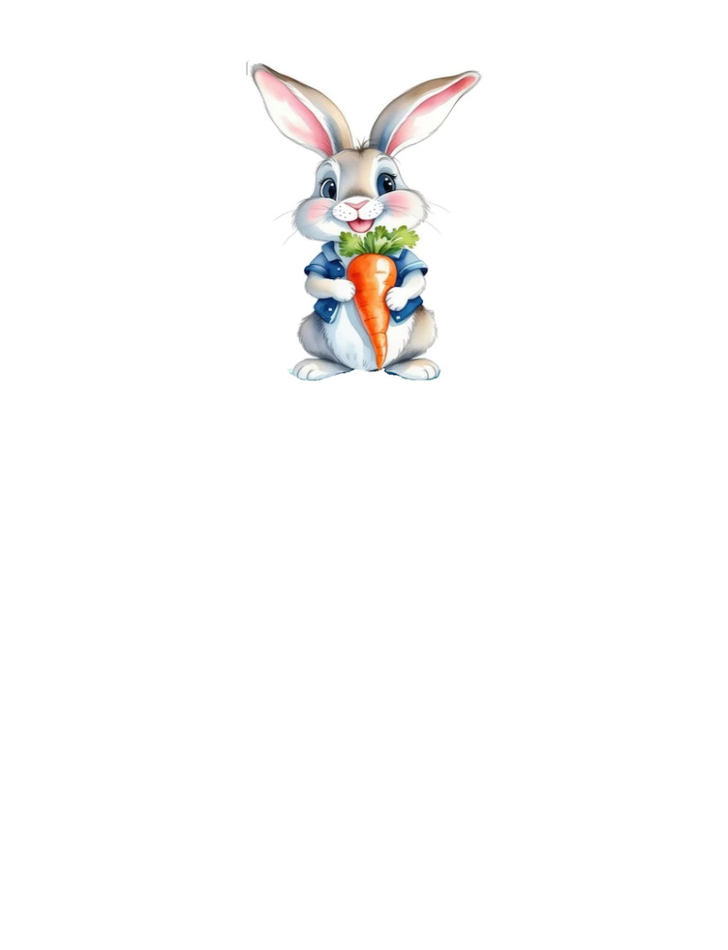
Peter Rabbit Playschool
127 2nd Avenue Newton Park, Port Elizabeth

Class Supplies

Babies (0-12 Month-olds)
Toiletries:
- Nappies (At least 6 per day)
- Wet Wipes (1 per Month)
- Bum Cream (1 per month)
- Baby Powder
- Box of Nappy bags. (1 every Term)
- 1 x Face Cloth
- 1 – 2 sets of clothing
- 1 x Receiving Blanket
- 1 x Warm Blanket
- Daily Formula
- Own Bottle
- 5 L Water per Term

It is your decision whether to send enough supplies for each day or to supply enough for the month.

2 Year class:
Toiletries:
- Wet wipes (1 per Month)
- Nappies (At least 6 per day)
- Bum Cream (1 per month)
- Box of nappy bags (1 every term)
- 2 x Box of tissues (Per term)
If your child is potty trained:
- 4 x Toilet Rolls (Per term)
- 1 x Liquid hand soap
- 1 x Colouring Book 240 page
- 2 x Big Wax Crayons
- 2 x 43gram Pritt
- Ice Cream container

- Face cloth
- Old T-Shirt or Apron
- Blanket
- 1 – 2 Sets Extra Clothing
- Something to drink
- Healthy Snacks

Reminders will be sent out to the WhatsApp group.

Peter Rabbit Playschool
127 2nd Avenue Newton Park, Port Elizabeth

Class Supplies
3-5 Year class:

Toiletries:
- 2 x Box of tissues (Per term)
- 4 x Toilet Rolls (Per term)
- 1 x Liquid hand soap
- 1 x Colouring Book 240 page
- 2 x Big Wax Crayons
- 2 x 43gram Pritt
- Ice Cream container

- Blanket
- 1 – 2 Sets Extra Clothing
- Face cloth
- Old T-Shirt or Apron
- Healthy Snacks
- Something to drink

Reminders will be sent out to the WhatsApp group.
Every little one will have his/her own shelf for their toiletries.
Everything sent to the school must be clearly marked with your child's name.
You are welcome to decorate your little one's Ice cream containers.

